**USER MANUAL**

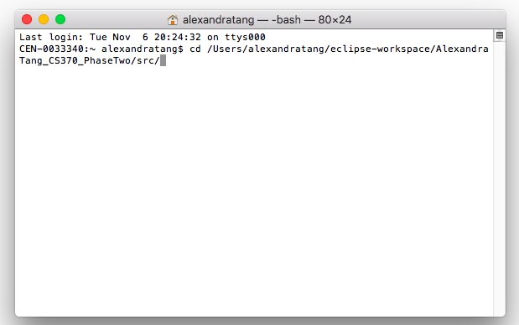

1. Navigate to the directory folder with all the files.  
   As shown on the right, that can be done by typing the following command: “cd [insert path here]”.

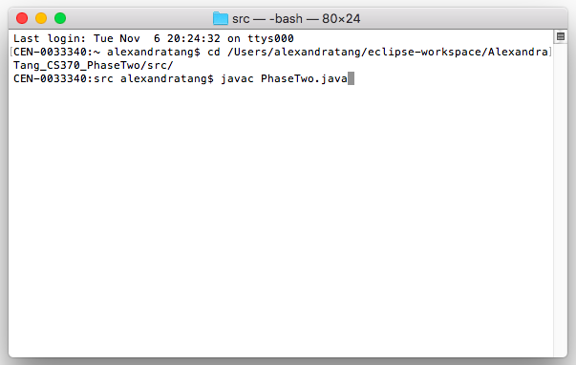

1. Compile the program .java files by typing:  
    “javac PhaseTwo.java”  
   This will create .class files in your directory.   
     
     
     
     
     
     
     
     
     
     
     
     
   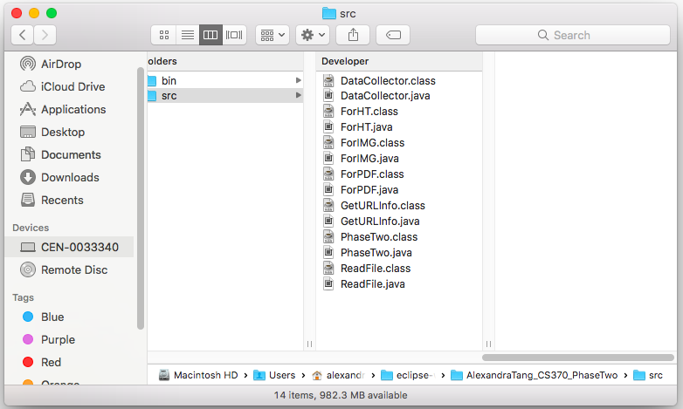  
     
     
     
     
   You can see the .class files, along with the .java files, in the image to the right.

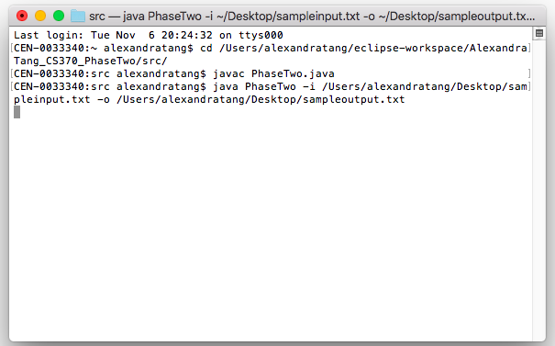

1. To use this program, you need to follow this template:  
   “java PhaseTwo –i [some input file].txt –o [some output file].txt”  
     
     
   **Note:** Your input file must exist, but your output file will be made for you. By default, your output file will be made in the directory in which this program resides. However, you can add the path as you would for the input file (see note below) to create the file there.  
     
     
     
     
     
     
     
     
   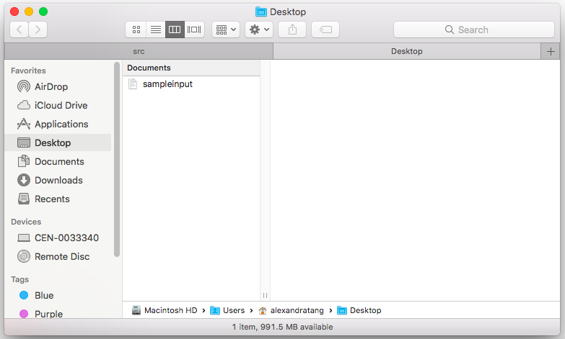  
     
     
     
     
     
     
   **Note:** If your input file is not in the same directory folder as the one this program is in, include the path prior to the “.txt” extension.  
   *Ex:* -i /Users/alexandratang/Desktop/sampleinput.txt  
     
     
     
     
     
     
     
     
   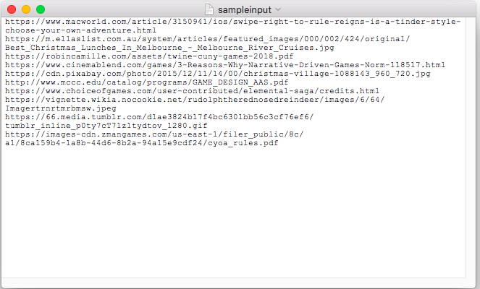  
     
     
     
     
     
     
   To the right, you can see what an input file should look like. URLs should be separated by a line.

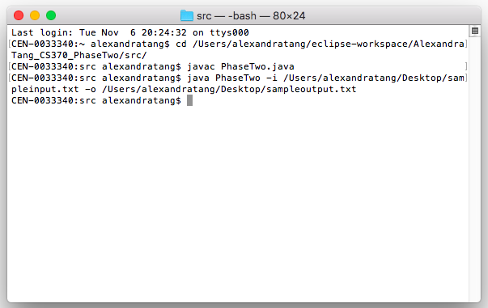

1. If the program has run successfully, you will return to a blank command line prompt where you are able to repeat step three with different files.

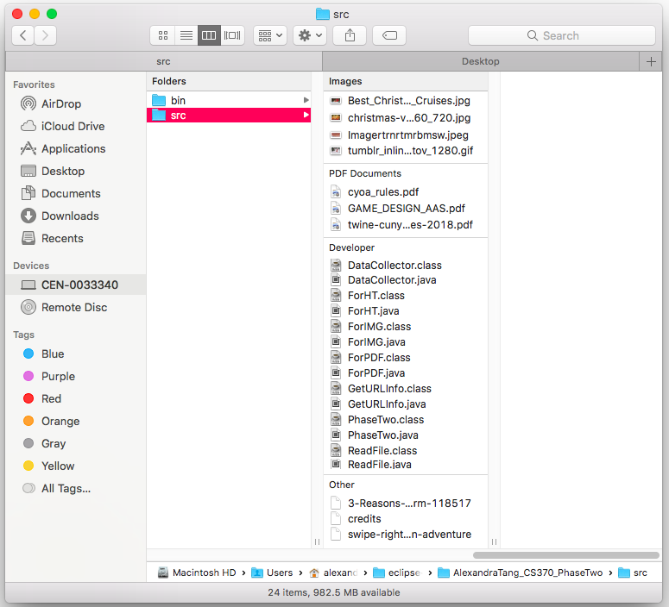

1. If the program has run successfully, you will see your image, PDF, and HTML/txt files in your working directory as shown in the image to the right.  
     
     
     
     
     
     
     
     
     
     
     
     
     
     
     
   Below are images of an HTML file created from a .HTML URL from the sample input file, a JPG file created from a .jpg URL in the sample input file, and a PDF file from a .pdf URL in the sample input.

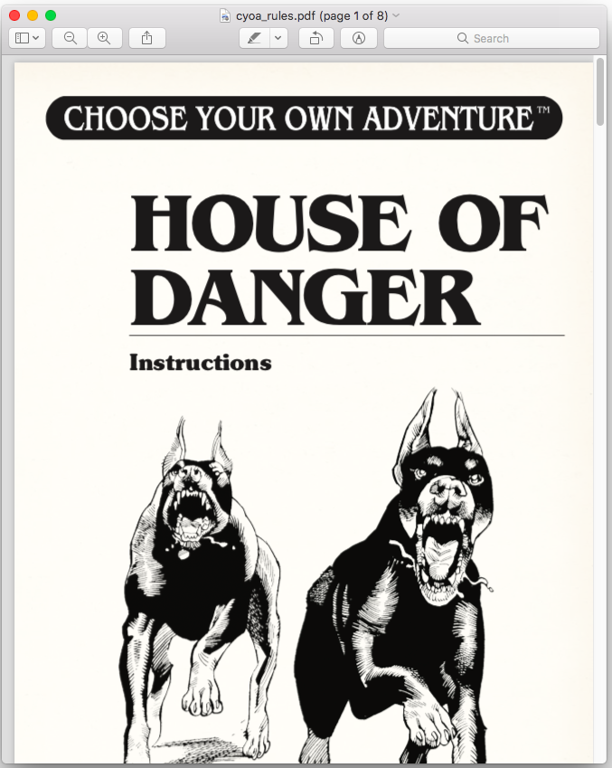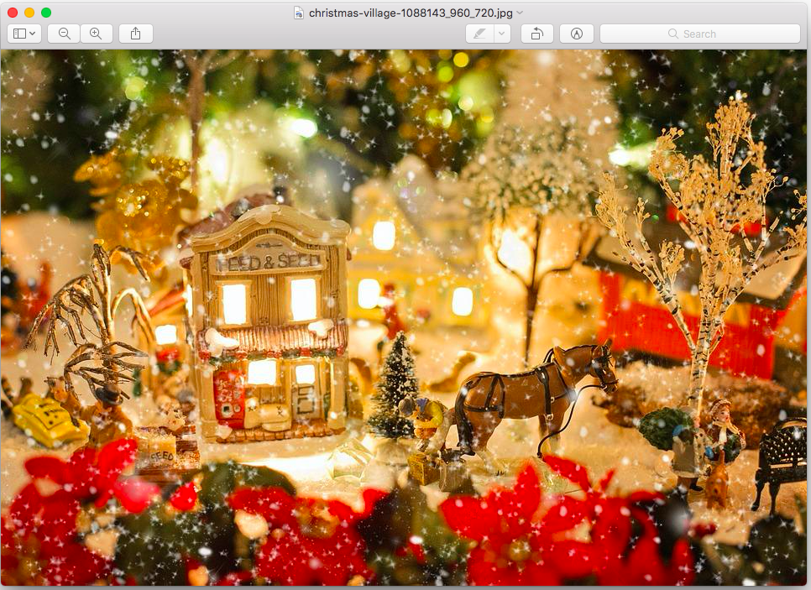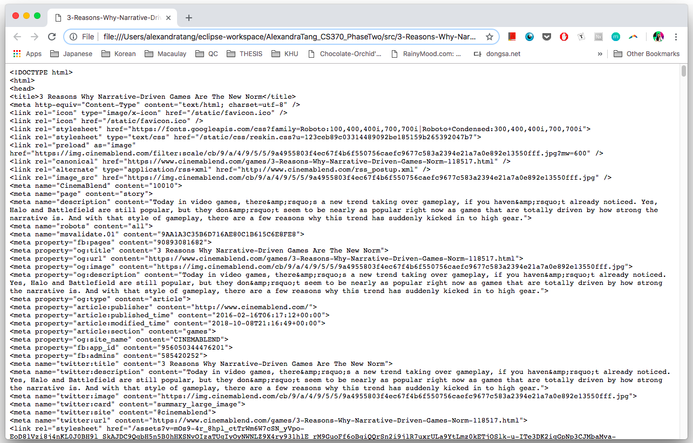

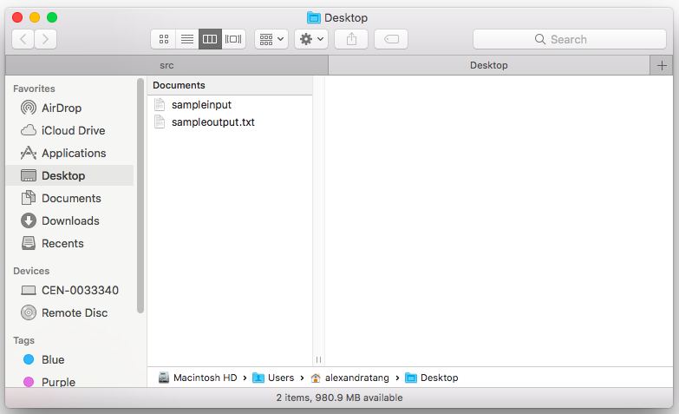

1. 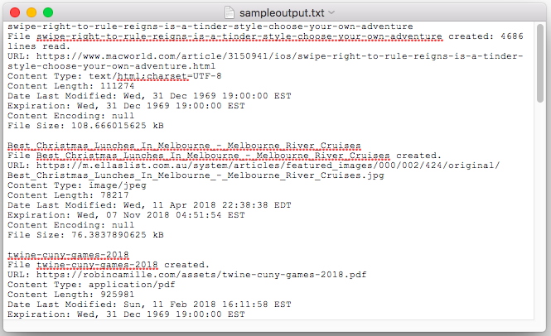If the program has run successfully, you will also see your output file wherever specified. If unspecified, it can be found in the working directory.  
     
     
     
     
     
     
     
     
     
     
     
     
     
     
     
     
     
   To the right, you can see an example of what an output file would look like. It will contain the URL name, if an HTML file: the number of lines counted, the full URL, content type, content length, date of last modification, expiration date, content encoding, and the file size.